IoT Course

Capstone Project   
Final Report

For students (instructor review required)

ⓒ2023 SAMSUNG. All rights reserved.

Samsung Electronics Corporate Citizenship Office holds the copyright of this document.

This document is a literary property protected by copyright law so reprint and reproduction without permission are prohibited.

To use this document other than the curriculum of Samsung Innovation Campus, you must receive written consent from copyright holder.

|  |
| --- |
| IoT-enabled Gas and Fire Detection |

< Date (23/07/2025) >

Team Name

Phạm Thu Hà

Hà Trung Thành

Nguyễn Duy Phúc

Nguyễn Tuấn Kiệt

Content

1. Introduction

1.1. Background Information

1.2. Motivation and Objective

1.3. Members and Role Assignments

1.4. Schedule and Milestones

2. Project Execution

2.1. IoT Service Model

2.2. Data Processing

2.3. Service Implementation

2.4. System Design

3. Results

3.1. Data Acquisition (Sensor, Actuator, Controller)

3.2. Network and Communication

3.3. Hardware Implementation

3.4. Data Visualization

3.5. Testing and Improvements

4. Projected Impact

4.1. Accomplishments and Benefits

4.2. Future Improvements

5. Team Member Review and Comment

6. Instructor Review and Comment

1. Introduction

1.1. Background Information

In recent years, the application of IoT (Internet of Things) in fire and gas detection systems has become increasingly popular due to the rise in industrialization and urbanization. Fires and gas leaks are two of the most dangerous risks that threaten human lives and property. Traditional fire alarm systems have certain limitations in terms of distance, mobility, and real-time notification. The integration of IoT into fire and gas detection enhances remote monitoring, real-time alerts, and efficient data logging, thereby improving safety and preventive actions.

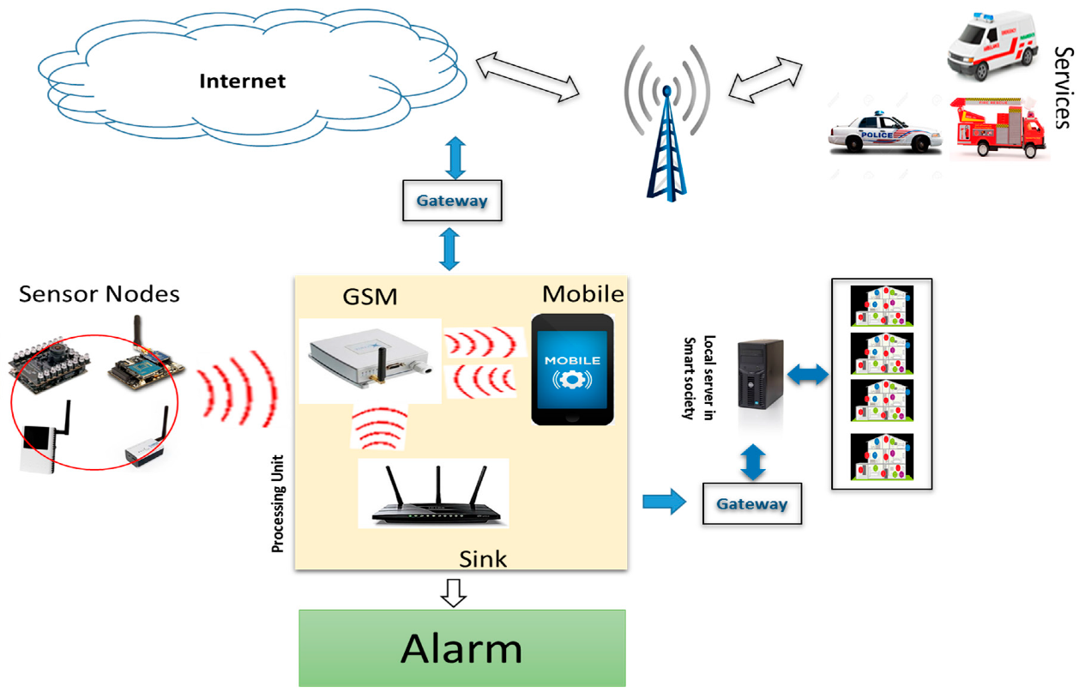

Figure 1.1: IoT-Based Intelligent Modeling of Smart Home Environment for Fire Prevention and Safety

1.2. Motivation and Objective

Our team chose to implement an IoT-based fire and gas detection system with the goal of developing a low-cost, effective, and easily deployable solution to monitor environmental conditions and detect potential hazards. The system is expected to notify users in real-time through a combination of hardware (sensors and controllers) and software (data visualization and analysis). Our objective includes gaining hands-on experience with technologies like Arduino IDE, Node-RED, and InfluxDB, as well as improving our team collaboration and problem-solving skills.

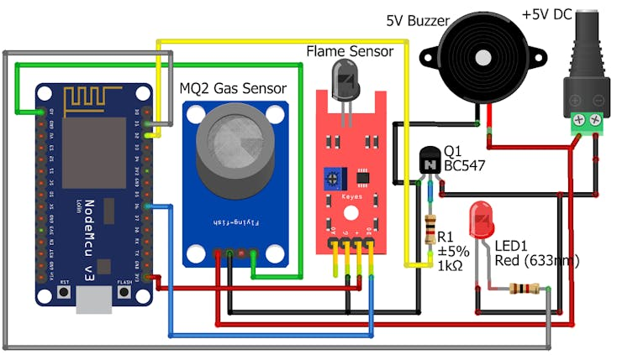

Figure 1.2: IoT Based Fire Alarm System Using ESP8266

1.3. Members and Role Assignments

**1. Phạm Thu Hà – Main Role: Data Analysis & Report Writing**

**Secondary Role: Sensor Programming**

**Main tasks:**

* Write the full technical report.
* Prepare and design the presentation slides.
* Analyze the sensor data collected from InfluxDB (gas, flame, temperature).
* Evaluate and record the system's accuracy and testing results.

**Secondary tasks:**

* Learn to program and adjust MQ2 and DHT11 sensors using Arduino IDE with Thanh’s guidance.
* Understand how Node-RED flows work and how real-time data is visualized on the dashboard.
* Try simple commands in InfluxDB to check and export data.

**2. Hà Trung Thành – Main Role: Programming & System Connection**

**Secondary Role: Report & Presentation Support**

**Main tasks:**

* Write Arduino code for MQ2 (gas), flame, and DHT11 (temperature) sensors.
* Configure MQTT communication between ESP8266 and Node-RED.
* Set up the connection between Node-RED and InfluxDB.
* Test the operation of each sensor and ensure real-time alerts are working correctly.

**Secondary tasks:**

* Support Hà in writing technical parts of the report related to code and flow.
* Make the Node-RED and InfluxDB integration slides for the presentation.
* Explain system data flow and logic in simple terms to the team.

**3. Nguyễn Tuấn Kiệt – Main Role: Hardware Testing & Dashboard Design**

**Secondary Role: Sensor Operation & System Stability**

**Main tasks:**

* Test sensor placement, wiring, and responses to real gas/fire sources.
* Help optimize sensor positions for better accuracy and fewer false positives.
* Design a user-friendly Node-RED dashboard interface to show gas/fire data, alerts, and temperature.
* Check the system’s responsiveness (LED/buzzer) during danger detection.

**Secondary tasks:**

* Assist in improving system stability during long runtime (heat, noise).
* Review Ha’s data analysis and report with a user-oriented view.
* Help Thanh debug dashboard display issues and give feedback for improvement.

**4. Nguyễn Duy Phúc – Main Role: Circuit Design & Power Supply**

**Secondary Role: System Safety & Hardware Integration**

**Main tasks:**

* Design the hardware connection circuit (sensors, ESP8266, buzzer, LED).
* Build the breadboard and permanent version of the system.
* Ensure stable power supply and proper voltage distribution.
* Monitor heat and wiring risks during testing.

**Secondary tasks:**

* Work with Kiệt to test system durability in real-life conditions (kitchen heat, distance).
* Help team simulate emergency scenarios and test power failures.
* Provide safety feedback and improvements for the hardware casing and sensor exposure.

1.4. Schedule and Milestones

* Week 1 – Planning and Research
* Discuss the idea and plan the system
* Learn about MQ2, DHT11, Node-RED, and InfluxDB
* Draw the system diagram
* Divide tasks between team members

Goal: Understand the project and tools

* Week 2 – Hardware and Sensor Programming
* Set up the MQ2 and DHT11 sensors
* Connect sensors to Arduino
* Test sensors and adjust the code
* Start writing report (introduction and system design)

Goal: Sensors work and give correct data

* Week 3 – Connect Node-RED and InfluxDB
* Send sensor data to Node-RED
* Create dashboard for live data
* Connect Node-RED to InfluxDB to store data
* Test data flow from sensors to database

Goal: Data flows from sensor to display and storage

* Week 4 – System Testing and Data Analysis
* Test full system with real data
* Analyze data from InfluxDB
* Check alert functions (LEDs, buzzer, dashboard)
* Write the results and analysis part of the report

Goal: System works and data is correct

* Week 5 – Final Report and Presentation
* Finish full report
* Make the presentation slides
* Practice presenting together
* Final system check and backup

Goal: Report and system ready for submission and presentation

2. Project Execution

2.1. IoT Service Model

The environmental monitoring system is built upon a typical IoT service model, which includes sensor endpoints, communication infrastructure, data processing platforms, and user-facing services. The system architecture follows a **three-layer model**: **Perception Layer**, **Network Layer**, and **Application Layer**.

**1. Perception Layer**

This layer consists of hardware devices that directly interact with the physical environment:

* **DHT22 Sensor**: Measures ambient temperature and humidity.

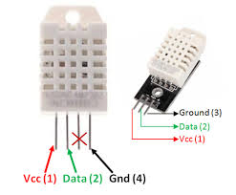

Figure 2.1: Sensor DHT22

* **MQ-2 Gas Sensor**: Detects concentrations of combustible gases such as LPG, carbon monoxide, and smoke.

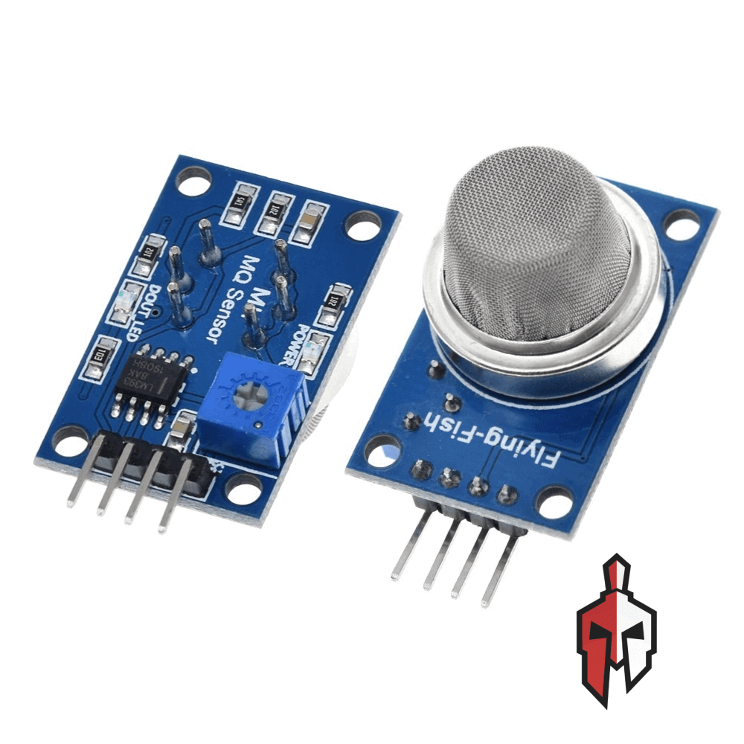

Figure 2.2: MQ‑2 Gas Sensor

* **Flame Sensor**: Detects fire presence using infrared light.

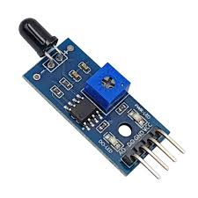

Figure 2.3: Flame Sensor

* **ESP8266 NodeMCU**: Acts as the central controller, collecting sensor data, performing preliminary processing, displaying data on an LCD screen, and activating the buzzer in case of emergency.

These components provide raw input data, forming the basis for monitoring and evaluating environmental conditions in real-time.

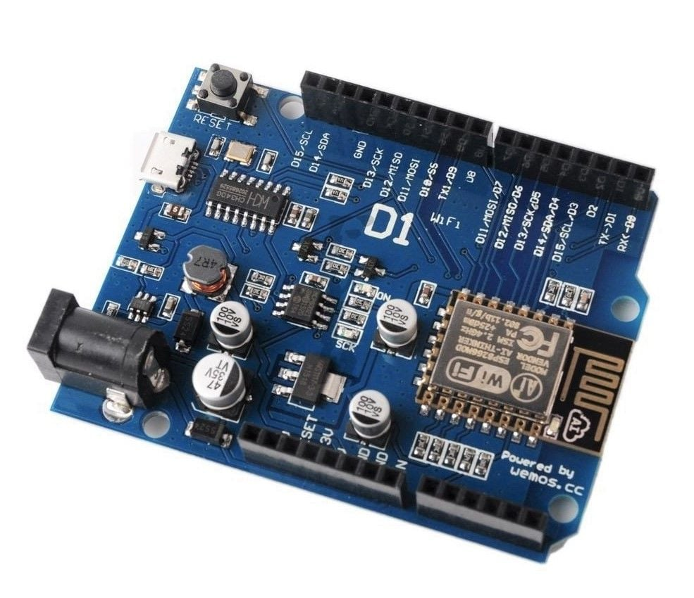

Figure 2.4: ESP8266

* **Buzzer:** Connected to a digital pin (e.g., D6), toggled via digitalWrite().

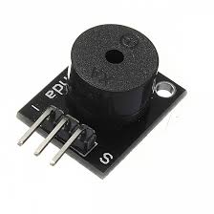

Figure 2.5: Buzzer

* **LCD I2C RGB:** Uses SDA and SCL lines; the LiquidCrystal_I2C library makes it easy to display data.

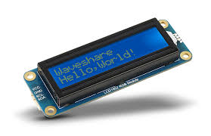

*Figure 2.6: LCD I2C RGB*

**2. Network Layer**

The network layer is responsible for transmitting data from edge devices to the central processing server. In this system, it includes:

* **WiFi (802.11 b/g/n)**: Enables the ESP8266 to connect to a local network.
* **MQTT (Message Queuing Telemetry Transport)**: A lightweight and efficient messaging protocol used to send sensor data from ESP8266 to the MQTT Broker with low latency.
* **MQTT Broker**: Acts as the intermediary that receives data from edge devices and forwards it to processing services like Node-RED and InfluxDB.

This layer ensures stable, continuous, and secure data communication throughout the system.

**3. Application Layer**

This is the layer where data is processed and presented to the user:

* **Node-RED**: A visual programming tool that receives MQTT messages, performs logical processing (e.g., detecting high temperature, gas, or fire), displays information on the dashboard, and triggers alarms or alerts.
* **InfluxDB**: A time-series database used to store sensor data for historical analysis and trend visualization.
* **Node-RED Dashboard**: Provides a user-friendly interface to monitor environmental parameters in real time using visual elements like gauges, line charts, and alerts.
* **Remote Alerting**: Node-RED can be integrated with platforms such as **Telegram** or **Email** to send real-time notifications to users, even when they are not physically present at the monitoring site.

2.2. Data Processing

In this system, data processing plays a vital role in ensuring accuracy and effectiveness in environmental monitoring. The processing starts immediately on the ESP8266 microcontroller. Here, raw data from sensors is continuously collected at fixed intervals. Signals such as:

* **Temperature and humidity** from the DHT22 (digital),
* **Analog values** from the gas sensor (MQ‑2),
* **Digital signal** from the flame sensor,

…are pre-processed with smoothing techniques, threshold checks, and formatted into appropriate structures (e.g., JSON strings) compatible with MQTT communication.

After this preprocessing on the device, data is sent to the MQTT broker. Node-RED receives these messages and further processes them: analyzing dangerous conditions, storing records in InfluxDB, and triggering alert services if abnormalities are detected. The standardized JSON format also supports dashboard display and historical analysis.

2.3. Service Implementation

The system offers multiple services to allow users to monitor and manage the environment intuitively and effectively:

* **Real-time monitoring:** Via the Node-RED dashboard, users can continuously track environmental metrics—temperature, humidity, gas levels, flame detection—with data refreshed live and displayed clearly via gauges, charts, and alerts.
* **Danger alerts:** When abnormal conditions occur (e.g., excessive temperature, gas levels beyond safe limits, flame detected), the buzzer alerts immediately on the device. In addition, Node-RED can send notifications via Telegram or email to keep users informed in real time.
* **Data storage:** Environmental data is saved into **InfluxDB**, a powerful time-series database, enabling users to track historical changes and support trend analysis and response planning.
* **Local display:** An I2C 16x2 LCD shows current temperature, humidity, and alarm status, allowing quick checks directly at the device.

These services work together in a synchronized way to provide fast, accurate, and continuous responses.

2.4. System Design

The system is designed according to a three-layer IoT architecture:

1. **Edge Layer (Sensor & Control):**
   * Includes sensors (DHT22, MQ‑2, Flame sensor) directly connected to the ESP8266.
   * The ESP8266 handles data collection, preprocessing, and transmission.
   * Peripherals such as the buzzer and LCD are also controlled by the ESP8266.
2. **Network Layer (Communication):**
   * The ESP8266 connects via WiFi for wireless networking.
   * **MQTT protocol** is used to transmit data efficiently and reliably to the processing server (Node-RED).
   * MQTT’s lightweight nature makes it ideal for IoT devices.
3. **Application Layer (Processing & Display):**
   * Node-RED receives the data and implements decision-making logic.
   * InfluxDB stores the time-series data.
   * The Node-RED dashboard provides visualization and alerting to the user.
   * Users can access the system remotely via a web interface or a mobile-friendly view.

This design supports scalability and easy maintenance, making it suitable for real-world monitoring applications.

3. Results

3.1. Data Acquisition (Sensor, Actuator, Controller)

Key hardware components involved in data acquisition include:

* **DHT22 sensor:** Measures ambient temperature and humidity with high accuracy, communicating digitally with the ESP8266.
* **MQ‑2 gas sensor:** Outputs an analog voltage corresponding to detected gas levels (LPG, smoke, methane), read via ESP8266’s A0 pin.
* **Flame sensor:** Detects infrared light emitted by flames and outputs a digital signal (LOW when flame is detected).
* **ESP8266 NodeMCU:** Serves as the central controller—collects sensor inputs, executes logic, sends data via MQTT, and manages the buzzer and LCD.
* **Buzzer alarm:** Activated if flame or gas levels exceed safety thresholds, providing local audible alerts.

Data acquisition occurs continuously at regular intervals (e.g., every few seconds) to ensure the information remains current.

3.2. Network and Communication

The system uses wireless networking (WiFi) to transmit data from devices to the server. Communication is handled via MQTT, a lightweight protocol ideal for IoT systems:

* **WiFi Connection:** The ESP8266 joins the local network or hotspot to ensure reliable data transfer to the server.
* **MQTT Broker:** Acts as an intermediary, receiving sensor data and distributing it to subscribers (like Node-RED). Topics include:
  + iot/temp: Temperature
  + iot/hum: Humidity
  + iot/gas: Gas concentration
  + iot/flame: Flame detection status
* **Node-RED:** Acts as an MQTT client—receiving, processing, and forwarding data to storage (InfluxDB) and visualization/dashboard services.

Using MQTT lowers latency and facilitates system scalability and reliable data transmission.

3.3. Hardware Implementation

Hardware deployment is carried out on an **ESP8266 NodeMCU board**, leveraging its GPIO pins for interfacing with different sensors and peripherals:

* **DHT22:** Connected to a digital pin (e.g., D4), powered by 3.3 V.
* **MQ‑2 Gas Sensor:** Connected to analog input A0; calibration may be performed after the sensor warms up.
* **Flame Sensor:** Connected to a digital pin (e.g., D5), outputs HIGH/LOW signal.
* **Buzzer:** Connected to a digital pin (e.g., D6), toggled via digitalWrite().
* **LCD I2C RGB:** Uses SDA and SCL lines; the LiquidCrystal_I2C library makes it easy to display data.

3.4. Data Visualization

Data visualization is crucial for enabling users to understand and monitor system status effectively. In this project, visualization is implemented across several platforms:

* **LCD RGB Display:** Shows real-time temperature and humidity values on the device itself for quick local reference.
* **Node-RED Dashboard:** A web-based interface that presents:
* **Gauges:** Real-time readings of temperature, humidity, and gas levels.
* **Line Charts:** Graphs depicting parameter changes over time.
* **Alerts:** Visual cues (e.g., red banners or flashing warnings) when dangerous conditions are detected.
* **InfluxDB:** Stores time-stamped data for future retrieval. Optionally, you can integrate with **Grafana** for advanced analytics dashboards (if needed).

3.5. Testing and Improvements

**Code in Arduino IDE:**

#include <Wire.h>

#include "rgb_lcd.h"

rgb_lcd lcd;

#include "DHT.h"

#include "EspMQTTClient.h"

#define DHTPIN D4

#define DHTTYPE DHT11

#define RELAY_PIN D6

#define COI_PIN D3 // Chân D3

#define BUTTON D2

#define FLAME_SENSOR_PIN D1 // Chân tín hiệu digital của cảm biến lửa

#define GAS_SENSOR_PIN D0 // Chân tín hiệu digital của cảm biến khí

#define INFLUXDB_URL "http://192.168.1.105:8066"

#define INFLUXDB_TOKEN "Jfkzbvj3pUQzYp5bZ8I38yfBWaabmwubpD2Qp8Dy225AVosk-gNAaKl6HVpZGH2LbECThI80xUbUS0RoqOy0eA=="

#define INFLUXDB_ORG "WGLabz"

#define INFLUXDB_BUCKET "Test"

#define INFLUXDB_MEASUREMENT "esp8266"

bool ledState = 0; // Trạng thái đèn

bool buttonPressed = 0;

DHT dht(DHTPIN, DHTTYPE);

EspMQTTClient client(

"Xom Tro",

"66668888",

"192.168.1.10", // MQTT Broker server ip

"MQTTUsername", // Can be omitted if not needed

"MQTTPassword", // Can be omitted if not needed

"TestClient", // Client name that uniquely identify your device

1883 // The MQTT port, default to 1883. this line can be omitted

);

//const int relayPin = 0; // GPIO0

void setup()

{

Serial.begin(9600);

dht.begin();

//setup RELAY

// set up the LCD's number of columns and rows:

lcd.begin(16, 2);

lcd.setRGB(255, 255, 255);

delay(1000);

pinMode(COI_PIN, OUTPUT); // Đặt D3 là OUTPUT

digitalWrite(COI_PIN, HIGH);

pinMode(BUTTON, INPUT_PULLUP); // Nút nhấn kéo xuống GND

Serial.begin(9600);

pinMode(FLAME_SENSOR_PIN, INPUT);

pinMode(GAS_SENSOR_PIN, INPUT);

client.enableDebuggingMessages();

client.enableHTTPWebUpdater();

client.enableOTA();

client.enableLastWillMessage("TestClient/lastwill", "I am going offline");

// Optional functionalities of EspMQTTClient

client.enableDebuggingMessages(); // Enable debugging messages sent to serial output

client.enableHTTPWebUpdater(); // Enable the web updater. User and password default to values of MQTTUsername and MQTTPassword. These can be overridded with enableHTTPWebUpdater("user", "password").

client.enableOTA(); // Enable OTA (Over The Air) updates. Password defaults to MQTTPassword. Port is the default OTA port. Can be overridden with enableOTA("password", port).

client.enableLastWillMessage("TestClient/lastwill", "I am going offline"); // You can activate the retain flag by setting the third parameter to true

}

void coi(int n)

{

digitalWrite(COI_PIN, HIGH); // Bật còi

delay(n); // Đợi 500ms

digitalWrite(COI_PIN, LOW); // Tắt còi

delay(n); // Đợi 500ms

}

void onConnectionEstablished()

{

Serial.println("ESP đã kết nối tới MQTT broker thành công!");

// Subscribe to "mytopic/test" and display received message to Serial

client.subscribe("mytopic/test", [](const String & payload) {

Serial.println(payload);

});

client.subscribe("mytopic/123test", [](const String & payload) {

Serial.println(payload);

});

client.subscribe("esp8266/relay", [](const String &payload) {

if (payload == "on") {

ledState = !ledState; // Đổi trạng thái

digitalWrite(RELAY_PIN, ledState); // Bật/tắt RELAY

//digitalWrite(RELAY_PIN, HIGH);

Serial.println("ĐỔI");

}

/*

else if (payload == "off") {

digitalWrite(RELAY_PIN, LOW);

Serial.println("OFF");

}

*/

});

}

void loop()

{

client.loop();

if (client.isConnected()) {

float h = dht.readHumidity(); // Đọc độ ẩm

float t = dht.readTemperature(); // Đọc nhiệt độ

int flame = digitalRead(FLAME_SENSOR_PIN); // Đọc cảm biến lửa

int gas = digitalRead(GAS_SENSOR_PIN); // Đọc cảm biến khí gas

digitalWrite(GAS_SENSOR_PIN,0);

digitalWrite(FLAME_SENSOR_PIN,1);

if (digitalRead(BUTTON) == LOW && !buttonPressed) {

buttonPressed = 1; // Đánh dấu đã nhấn

ledState = !ledState; // Đổi trạng thái

delay(100); // đợi tránh dội nút

}

// Nếu đã nhấn và thả tay ra

if (digitalRead(BUTTON) == HIGH) {

buttonPressed = 0; // Sẵn sàng nhận lần nhấn tiếp theo

}

if (isnan(h) || isnan(t)) {

Serial.println("Loi doc DHT11");

lcd.clear();

lcd.setCursor(0, 0);

lcd.print("DHT loi!");

delay(200);

return;

}

//Cảm biến khí Gas & Cháy

if ((ledState==0)&&(flame==0))

{

coi(250);

Serial.print("Flame: ");

Serial.println("Cháy rồi!");

}

else if ((ledState==0)&&(gas==1))

{

coi(700);

Serial.print("Gas: ");

Serial.println("Khí Gas vượt ngưỡng");

}

else {

digitalWrite(COI_PIN, LOW); // Còi tắt ngay lập tức

}

// Tạo chuỗi JSON hợp lệ

String jsonData = "{\"temp\":" + String(t, 1) + ",\"humi\":" + String(h, 1) + "}";

Serial.println("Gửi JSON: " + jsonData);

//HIEN THI NHIET DO, ĐỘ ẨM LÊN LCD

lcd.clear();

lcd.print("temp: ");

lcd.setCursor(6, 0);

lcd.print(h,1);

lcd.setCursor(0, 1);

lcd.print("humi: ");

lcd.setCursor(6, 1);

lcd.print(t,1);

delay(100);

// Gửi lên MQTT

client.publish("mytopic/sensor", jsonData.c_str());

}

else {

Serial.println("MQTT chưa kết nối. Đợi tiếp...");

lcd.clear();

lcd.setCursor(0, 0);

lcd.print("MQTT connecting...");

delay(100);

}

delay(200);

}

**Node-RED Integration**

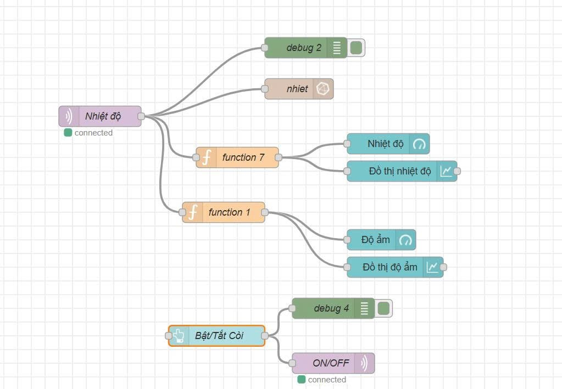

**Data is saved in InfluxDB**

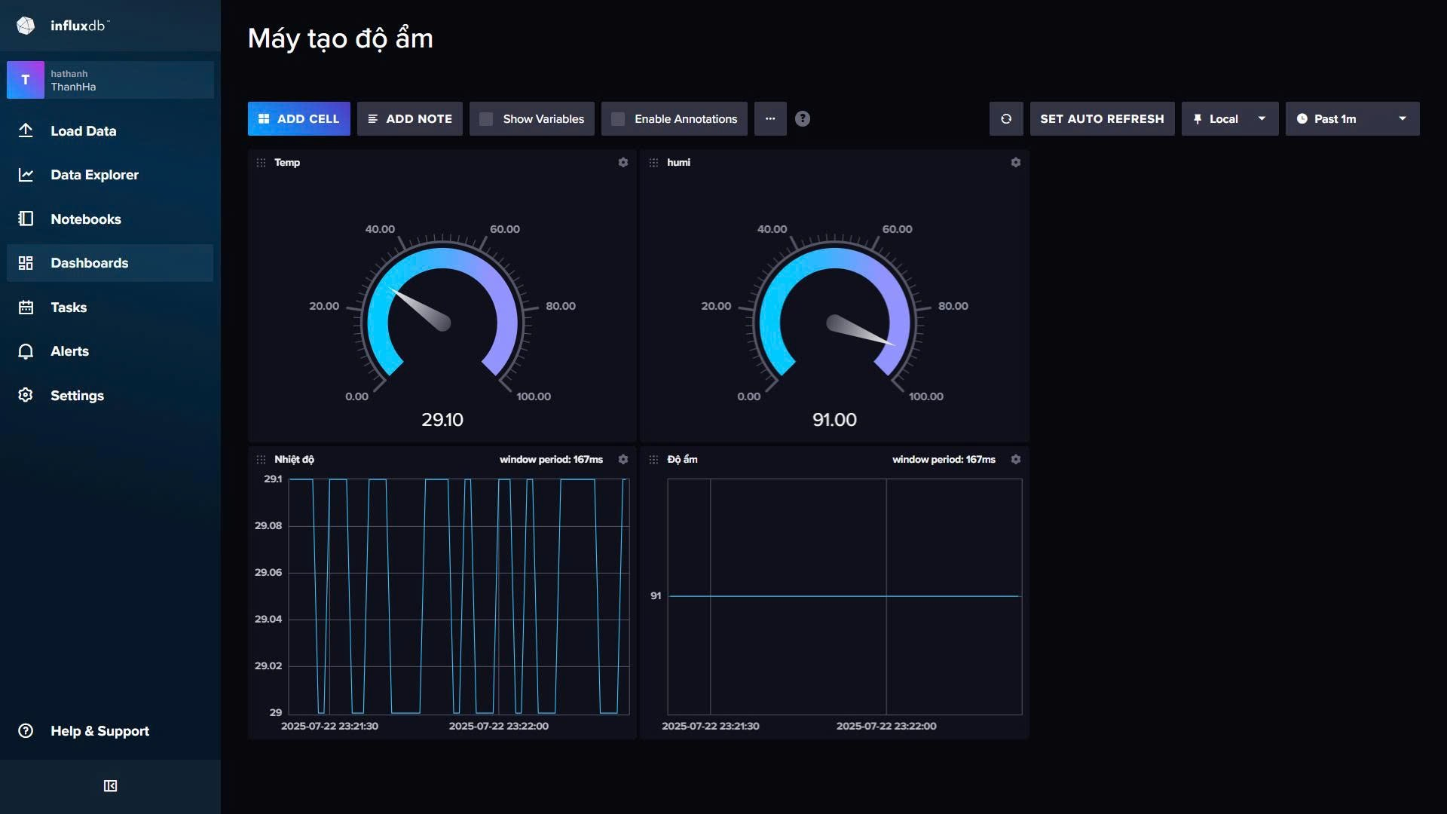

**Real product:**

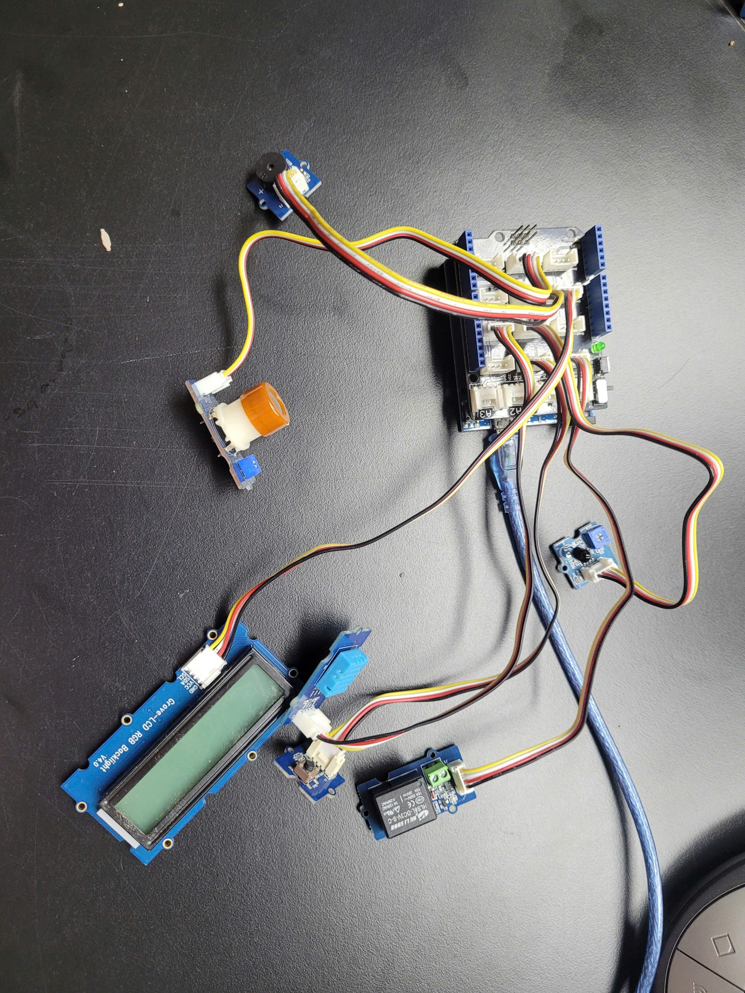

Figure 3.1: Real product

4. Projected Impact

4.1. Accomplishments and Benefits

The real-time gas and fire monitoring system using IoT technology not only creates a working product but also brings many academic and practical benefits:

* **Raising community awareness:** Thanks to the system's ability to detect gas leaks and fire risks in real time, users can stay safe and prevent accidents early. This is helpful for homes and small factories.
* **Good real-life experience for the team:** Team members learned how to connect software (like Node-RED, MQTT, InfluxDB, Dashboard...) with hardware (ESP8266, MQ2 gas sensor, DS18B20 temperature sensor...). This helped the team understand how to build an IoT system from theory to real practice.
* **Expandable solution:** The system is made in an open way. That means more sensors or functions can be added easily. It can work in homes, buildings, or small factories.
* **Helps protect people and the environment:** Early alerts about fire or gas help reduce danger and damage. It also encourages people to use smart technology in daily life to make things safer and better.

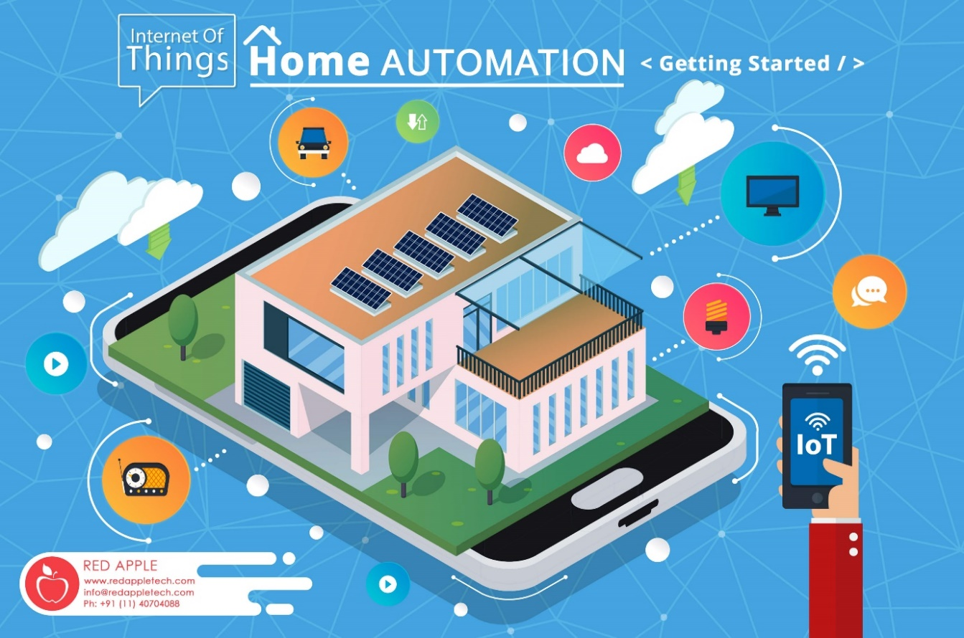

Figure 4.1: Smart House using IoT

4.2. Future Improvements

The project does not stopat building a working model but also opens many ways to improve it in the future. The team suggested some ideas to make the system more reliable, independent, and smart:

* **Add SMS or email alert when Wi-Fi is lost:**  
  If the Wi-Fi is not working, the system will use a GSM module to send a warning message to a saved phone number. This helps the system give alerts even without Wi-Fi.  
  Also, the system can send emails or use apps like Telegram or Zalo for office users.
* **Add more types of sensors:**  
  Add temperature sensor, CO₂ sensor, and vibration sensor to check the environment better. These can help find problems like small fires, electricity faults, or gas leaks from heaters or stoves.  
  These sensors can work together and send early warnings when something is wrong.
* **Use artificial intelligence (AI):**  
  Use machine learning to study sensor data for a long time. The system can find dangerous patterns that may cause fire or gas leaks.  
  It can also learn from old problems and change the warning level for each place like kitchens, labs, or storage rooms.
* **Make a mobile version with battery and 4G:**  
  Create a version with a battery and 4G internet. This version can work in places without Wi-Fi or stable power.  
  It is useful for outdoor areas, construction sites, mobile chemical storage, or in rescue situations.

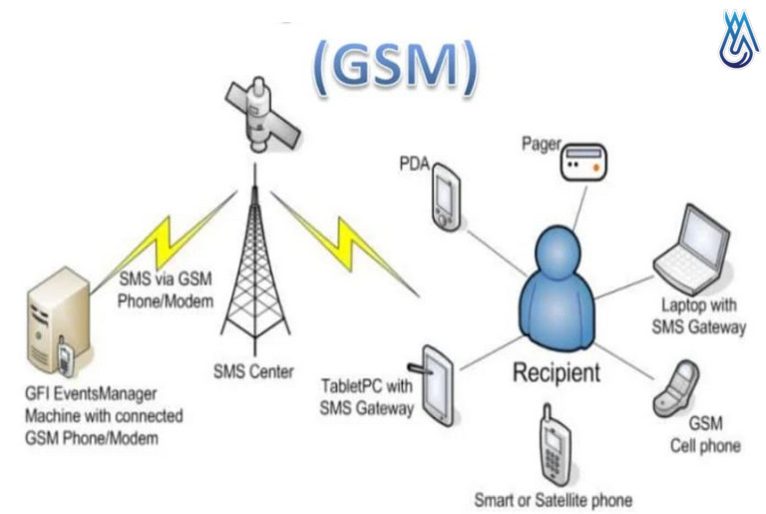

Figure 4.2: Improved schematic integrates additional GSM module, battery and 4G.

5. Team Member Review and Comment

|  |
| --- |
| Figure 4.3: Product |

|  |  |
| --- | --- |
| NAME | REVIEW and COMMENT |
| Ha | In this project, I worked mainly on writing the report, making the presentation slides, analyzing sensor data from InfluxDB, and checking how accurate the system is. These tasks helped me improve my writing and technical understanding.  At first, I didn’t know much about programming or IoT systems. But with help from Thanh and Kiet, I learned how to use Arduino IDE, how to read sensor values, and how to understand the real-time data on the Node-RED dashboard. I also practiced some basic InfluxDB queries to see the history of the gas and fire sensor values.  By looking at the data and testing the system, I learned how important it is to check the numbers carefully. I became more patient and more careful when writing reports and explaining the results.  What I learned:   * How to write a technical report step by step. * How to analyze sensor data using graphs and charts. * Basic programming with Arduino and sensor calibration. * How the full IoT system works (ESP8266, sensors, MQTT, dashboard). * How to work in a team and share ideas.   Comment: This project helped me grow. I feel more confident in reading data, writing reports, and talking about technical things. Thanh supported me a lot with sensor code. Kiet helped test the system with me. Phuc helped design the dashboard for clear data display. We all worked well together and learned from each other. |
| Thanh | My main job was technical. I connected the sensors, wrote code using **Arduino IDE**, and made sure the system worked. I also helped Ha understand sensor programming and Node-RED.  During this project, I solved many problems, like data not showing on the dashboard or sensor values not correct. I improved my **debugging skills**, learned more about **MQTT**, and made the system more stable. I also worked with **Node-RED**, created flows, and sent data to **InfluxDB**.  **What I learned:**   * How to build a complete IoT system. * How to use sensors (MQ2, Flame, DHT11) with ESP8266. * How to set up MQTT, Node-RED, and InfluxDB. * How to fix connection and communication errors. * How to explain technical ideas to friends.   **Comment:** I really liked working on this project. I could apply what I learned in class and get better at coding and teamwork. **Ha** asked good questions and learned fast. **Kiet** helped me test hardware. **Phuc** gave feedback on the interface. We helped each other, and it was a great experience. |
| Phuc | My task was to work on the **circuit design** and **power supply** of the system. I made sure all the components were connected correctly, and that the power was stable.  I helped build the system on a **breadboard**, and later helped make a **permanent version**. I checked if the sensors had enough power and if the buzzer and LED worked correctly when gas or fire was detected.  **What I learned:**   * How to design simple circuits for sensors and microcontrollers. * How to check power levels and fix connection problems. * How to test the system with real gas and fire. * How to support teammates with hardware setup.   **Comment:** I learned a lot about power systems and how to support sensors. I also learned how to work with software teammates. **Thanh** helped check the code. **Ha** made the report very detailed. **Kiet** tested with me and gave ideas for safety. We worked well together and finished the project successfully. |
| Kiet | I worked on **testing the hardware**, checking sensor placement, and helping to make the **Node-RED dashboard** clear and easy to use. I also checked that the buzzer and LED alarms worked at the right time.  I helped **Ha** understand how to show sensor values on the dashboard. I also supported **Thanh** in testing the Wi-Fi connection and fixing bugs. I spent time designing how the dashboard looks, using graphs, colors, and labels to make the information easier to read.  **What I learned:**   * How to test sensors and check warning signals. * How to use Node-RED to show sensor values in real time. * How to work with other team members and give support. * How to build a clear and useful dashboard.   **Comment:** This project helped me feel more confident in testing and interface design. I also learned how to connect many parts together. **Thanh** was very good at coding. **Ha** was careful with the report. **Phuc** worked with me on interface display. I enjoyed the teamwork. |

6. Instructor Review and Comment

|  |  |  |
| --- | --- | --- |
| CATEGORY | SCORE | REVIEW and COMMENT |
| IDEA | __/10 |  |
| APPLICATION | __/30 |  |
| RESULT | __/30 |  |
| PROJECT MANAGEMENT | __/10 |  |
| PRESENTATION & REPORT | __/20 |  |
| TOTAL | __/100 |  |